**Home Page : In the Home page Add this below part ….**

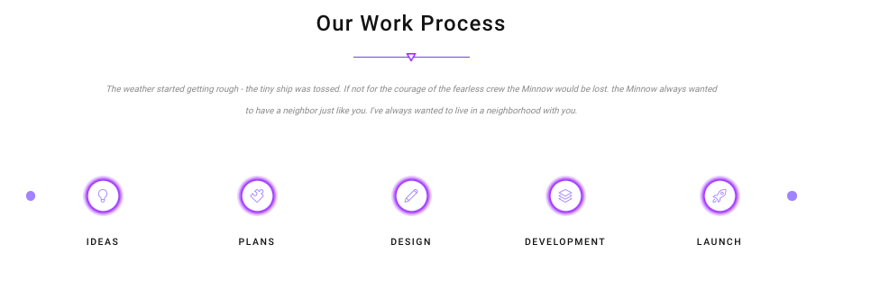

Our Work Process

-------m-------

Our Design, Engineering, Production & QAQC, Testing Team are fully trained to work as per the Client & Consultant requirements with the following Process.

|  |  |  |  |  |
| --- | --- | --- | --- | --- |
| Complying Specification | Design & Engineering | Production | Quality control, Testing & Delivery | Site Testing & Commission support upto Project Handing over |

Approvals

-------m-------

Remove Featured works & put as “Client Approvals”

Add these Logos as per the attached…

1. All logos only enough – no need of wording
2. 4nos of Images per row – please make 6nos. per row



[add these logos in the above photos …](http://www.startswitchgear.com/certification/)

[http://www.startswitchgear.com/client-complaince/](http://www.startswitchgear.com/certification/)